3 Ingredient Nutella Brownies
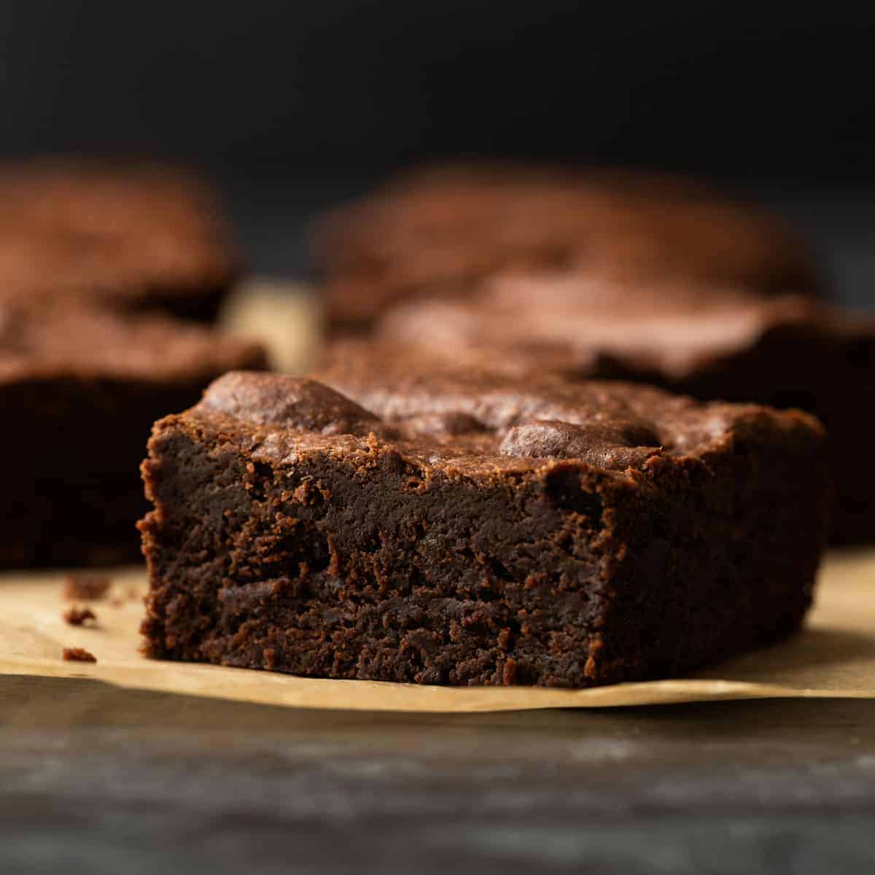

INGREDIENTS
- 1 cup (240 gram) Nutella
- 2 eggs
- 10 tablespoons (85 gram) all-purpose flour
- Baking pan and panko spray
- Servings: 10-12
PREPARATION
- Step 1 Put on the oven at 175˚C and spray the baking pan with panko spray.
- Step 2 Put the Nutella, eggs, and flour in a large bowl and mix until all ingredients are combines. The batter should be thick and shiny.
- Step 3 Pour the batter into your baking pan or mold.
- Step 4 Baking: 175˚C for more or less 20 to 25 minutes.
The all-purpose flour is available at Caribbean Bakery Supplies!

